Ciprian T Seceac
MIDDLESEX UNIVERSITY BSC COMPUTER SCIENCE
STUDENT ID: M01066754
project report

1.GitHub Repository:
https://github.com/ciprianseceac-boop/CW2_M01066754_CST1510.git

2.Introduction
The Multi-Domain Intelligence Platform is a Streamlit-based application designed to integrate secure authentication, structured data management, and interactive dashboards into a single, user-friendly system. Its purpose is to provide professionals with actionable insights across multiple domains — Cybersecurity, Data Science, and IT Operations — by combining database functionality with real-time analytics and visualization. The platform emphasizes modularity, maintainability, and security, ensuring that sensitive information is protected while still being accessible in a clear and interactive format.
At its core, the platform enables users to register and log in securely, store and manage incident data, and analyse patterns through dashboards. By leveraging SQLite for structured storage and bcrypt hashing for password protection, the system ensures that user credentials and incident records remain secure. Once authenticated, users can access dashboards that present key metrics, trends, and recommendations, helping them make informed decisions about incidents and workflows. The design reflects professional practice by combining technical robustness with accessibility for non-technical users.
For my implementation, I chose the Cybersecurity domain, as it provided the opportunity to explore incident management, phishing detection, and workflow analysis. Within this domain, I implemented Tier 2 functionality, which required secure login, database integration, CRUD operations, and interactive dashboards. This tier allowed me to move beyond basic authentication and storage, creating a system that not only protects user data but also visualizes cyber incidents in meaningful ways. Features such as phishing spike detection, severity distribution charts, and automated recommendations demonstrate how the platform can support proactive security management.
By focusing on Cybersecurity at Tier 2, my project highlights both technical skills such as secure coding and modular design and applied problem-solving, ensuring the platform is practical and professional.

3. How I Built the System

3.1 Security & Database
Security was the foundation of my project. To protect user passwords, I used the bcrypt library. Instead of storing plain text passwords, bcrypt applies a process called hashing. Hashing converts the password into a long string of characters that cannot be reversed back into the original password. Even if someone accessed the database, they would only see the hashed values, not the actual passwords. I also used salting, which adds random data to each password before hashing, ensuring that even identical passwords produce different hashes.
Data is stored in an SQLite database called intelligence_platform.db. This database contains two main tables:
- Users table: Stores usernames and their hashed passwords. Each username must be unique.
- Cyber Incidents table: Stores incident details such as ID, timestamp, severity, category, status, and description.
Security matters because the platform deals with sensitive information. Without hashing, user credentials could be stolen and without structured storage, incident data could be corrupted or misused. By combining hashing with a relational database, I ensured that both authentication and incident management are secure and reliable.

3.2 System Structure
The system follows a clear flow from login to dashboard:
User → Login Page → Authentication → Database → Dashboard → User Interaction
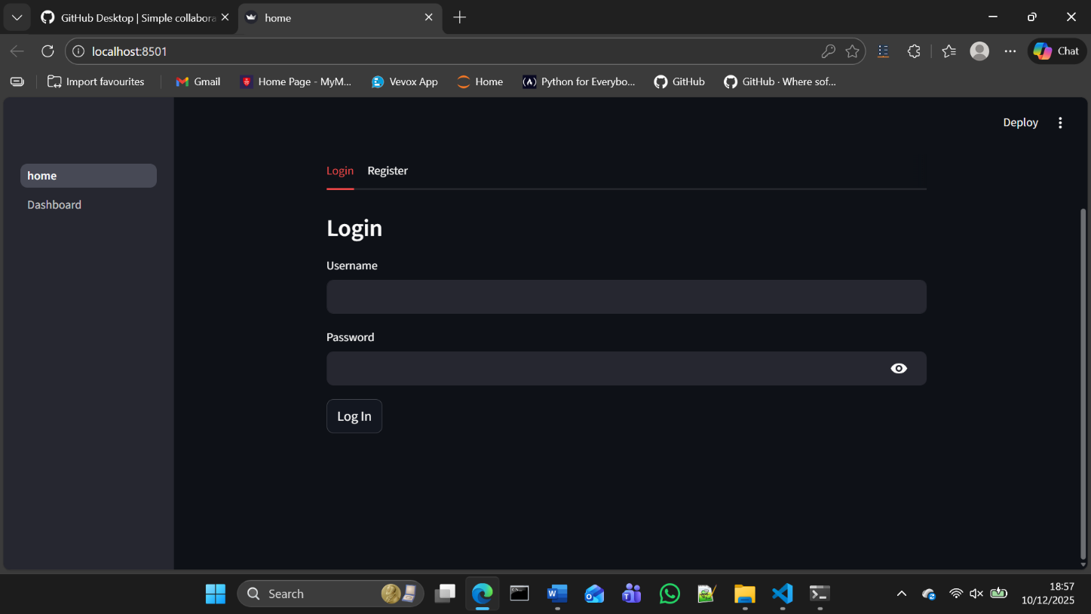
Figure 1: Home Page with Login and Registration Tabs.
- Login Page (home.py): Users can register or log in. Registration hashes the password before saving it. Login verifies the entered password against the stored hash.
- Authentication (users.py): Handles password hashing, verification, and CRUD operations for users.
- Database (schema.py, db.py): Stores user and incident data.
- Dashboard (Dashboard.py): Displays metrics, charts, and recommendations.
- User Interaction: Users filter incidents, view analytics, and receive recommendations.
Data Flow Explanation:
- A user enters their credentials on the login page.
- The system checks the database for the username and verifies the password using bcrypt.
- If successful, the user session is stored in st.session_state.
- The dashboard retrieves incident data from the database.
- Streamlit visualizes the data with charts and metrics.
- The user interacts with filters and receives updated results instantly.
This flow ensures that information moves seamlessly from user input to secure storage and finally to visual display.

3.3 Code Organization (OOP Refactoring)
I organized my code into modules and also implemented Object-Oriented Programming (OOP) for incident management.
- User functions (users.py): Handle registration, login, and password hashing.
- Incident functions (cyber_incidents.py): CRUD operations and analytics for incidents.
- SecurityIncident class (models.py): Encapsulates incident data and methods for create, read, update, delete, and analytics.
Class Diagram:
The SecurityIncident class connects directly to the database and provides reusable methods for incident management. This refactoring made the code cleaner and easier to maintain. For example, instead of writing separate SQL queries each time, I could call incident.update() or incident.delete(). It also improved readability and reduced duplication.
SecurityIncident
- incident_id
- severity
- category
- status
- description
+ create()
+ load()
+ update()
+ delete()
+ analytics()

Database Manager
+ connect()
+ migrate()
+ query()

User
- username
- password_hash
+ register()
+ login()

Figure 2: Class diagram showing OOP refactoring.

3.4 Key Features
The dashboard provides several interactive features:
- Key Metrics: Displays total incidents, number of critical cases, open cases, and phishing attacks.
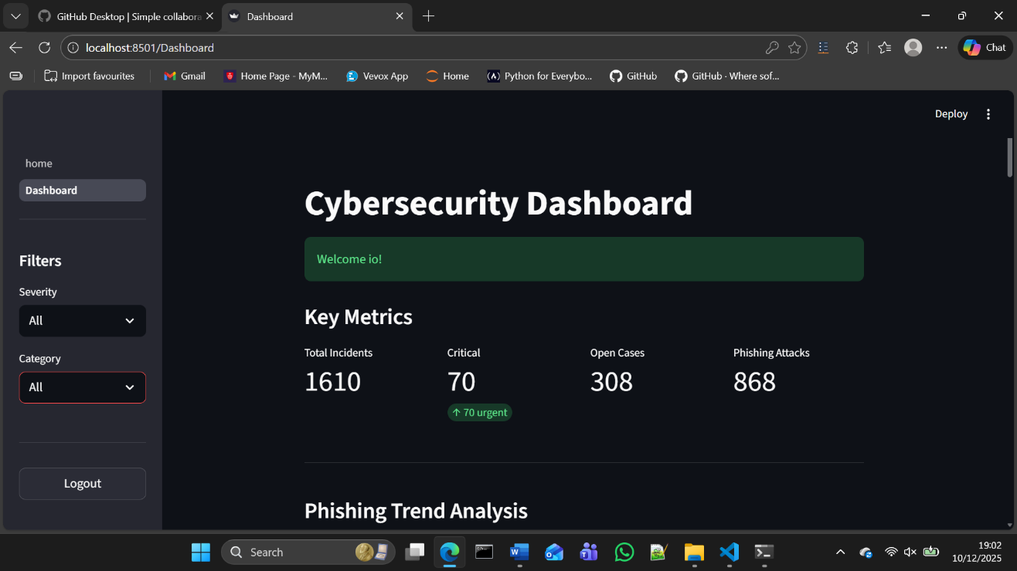 Figure 3: Dashboard showing key metrics.

- Phishing Trend Analysis: Line chart showing phishing incidents over time. If a spike exceeds 150% of the average, a warning is displayed with recommendations.
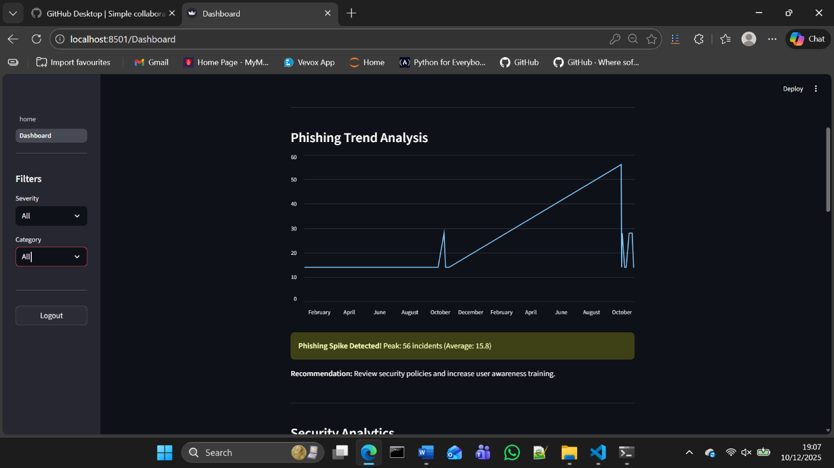 Figure 4: Phishing incidents trend line chart with spike detection warning.

- Severity Distribution: Bar chart showing the number of incidents by severity (Critical, High, Medium, Low).
- Category Breakdown: Bar chart showing incidents by category (Phishing, Malware, Misconfiguration, etc.).
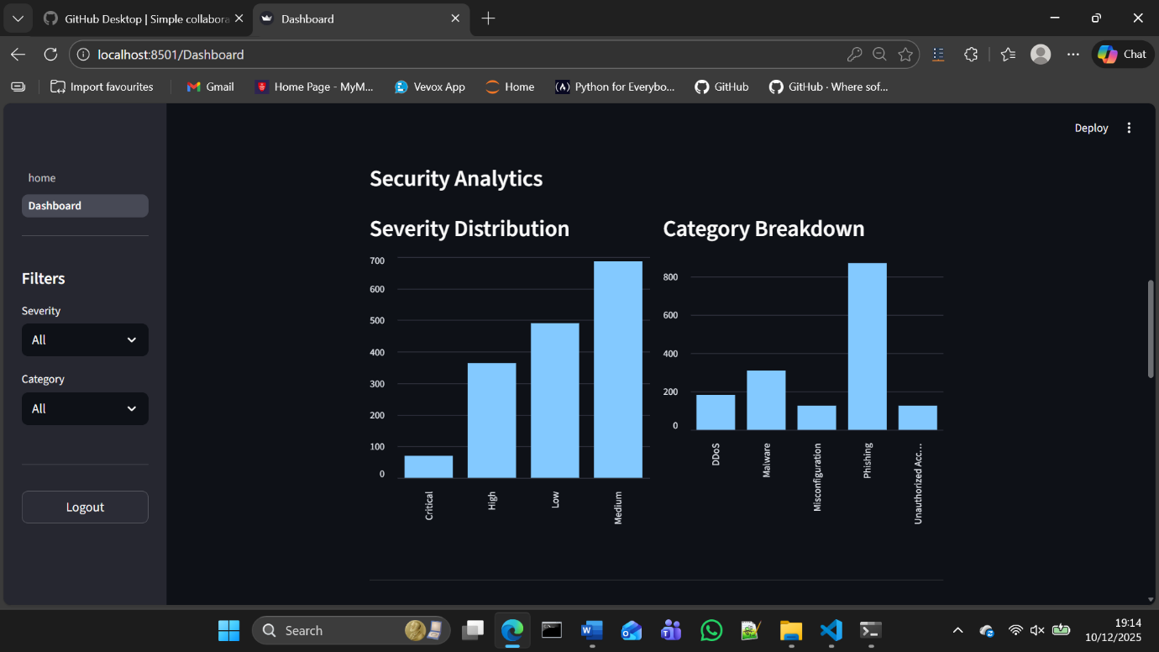 Figure 5: Bar chart showing incident severity distribution and incident categories.
- Workflow Analysis: Charts showing status overview (Open, Resolved, Closed) and incidents over time. 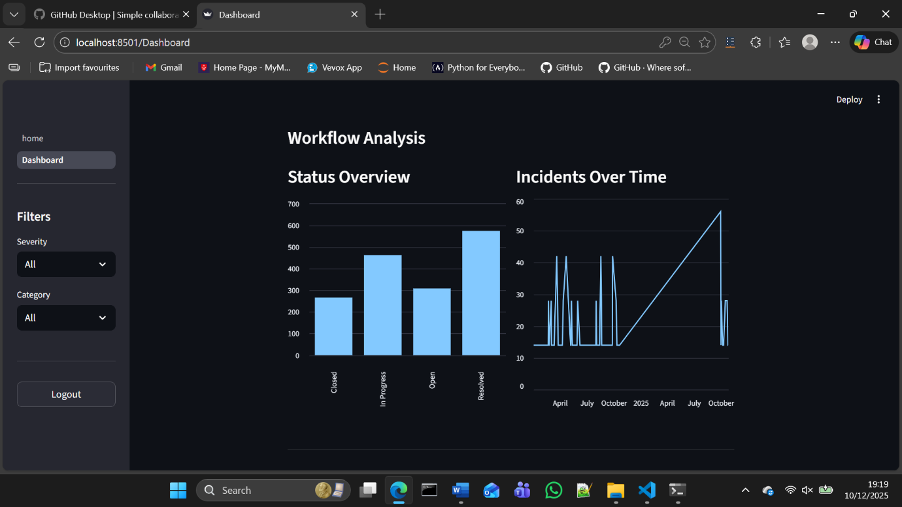 Figure 6: Workflow analysis charts – status overview and incidents timeline.
- Recommendations: Automated alerts for critical open incidents, phishing spikes, high open rates, and workflow issues.
- Incident Details: A full table of incidents with filters for severity and category, allowing users to drill down into specific cases.
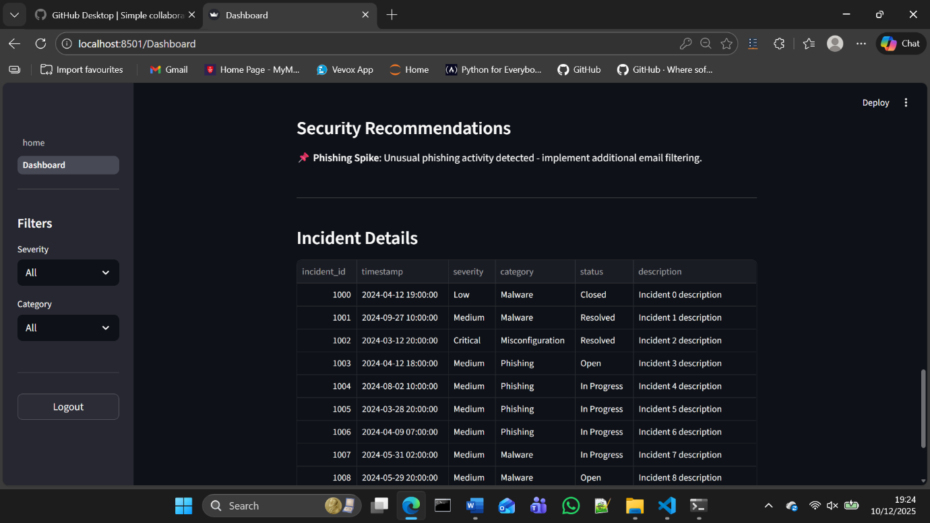Figure 7: Security recommendations displayed on the dashboard and Incident details table with filters for severity and category.
These visualizations make the system practical and user-friendly. Instead of reading raw data, users can quickly see trends, risks, and recommended actions.

4. Reflection & Conclusion

4.1 What I Learned
This project has been a real learning journey for me. One of the most valuable things I gained was confidence in building something from start to finish. At the beginning, I was mainly focused on making the code work, but as I progressed, I started to think more about my development and how the system feels for the user, how secure it is and how easy it is to maintain.
I learned that small details such as the way a login page remembers a user or how information is displayed on a dashboard can make a significant difference to the overall experience. I also learned about the importance of keeping things organised — breaking the project into clear sections and modules helped me stay on track with baseline of it — and made the system easier to understand.
Overall, my understanding shifted from writing a code to thinking as a developer would, considering usability, security, and clarity all at once.

4.2 Challenges I Faced
My development so far in this project was not without challenges. The main challenge I encountered was making sure the system kept users logged in properly as every time someone moved between pages, they were logged out. By changing the code, I managed to keep that information stored so that the experience felt seamless.
Another challenge I was faced with was working with the database as at times, the data did not load the way I expected and the queries did not give me the right results. I learned that I need to steady my pace, test everything step by step and not rush through errors. This approach has enabled me to solve those problems therefore the system felt much more reliable.
These challenges taught me resilience and I started to see the errors more like learning opportunities rather than failure.

4.3 Conclusion
Reflecting on my journey so far, I believe I achieved valuable skills. Among my achievements I can pinpoint things such as building a platform that allows users to log in securely, managing incident data and clear visualisation of trends and risks. I learned that the dashboard does not only show numbers, but it is also giving meaningful insights such as spotting spikes in phishing activity and highlighting critical cases that need attention.
If I were to take this project further, I would like to add an AI assistant that could answer questions in plain language thus making the system more accessible. I would also expand the dashboards to cover other domains so that users could compare cybersecurity data with IT operations or data science insights.
This project has given me not only technical skills but also confidence in my ability to design a useful and professional dashboard. Moreover, it showed me that persistence and reflection are just as important as writing code.

